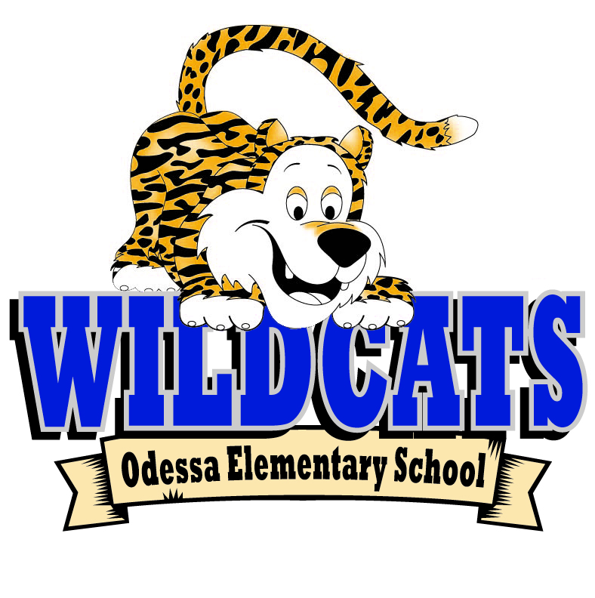
Odessa Elementary School
Fifth Grade Supply List 2022-2023
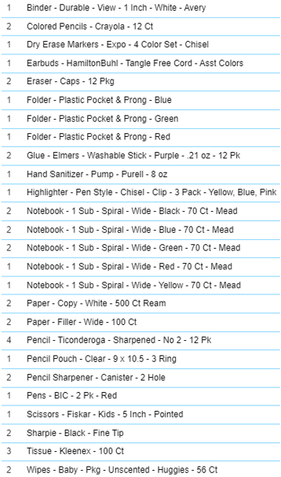
Boys: Ziplock- Gallon Size
Girls: Ziplock- Quart Size

